HuskyLens Object-Tracking Test Results
HuskyLens was interfaced with the ESP32-S3 Zero and configured in object-tracking mode. Serial output (time_ms, id, x, y, width, height) was logged in three independent runs (~60 s each) under fixed camera placement and consistent scene conditions. Performance was evaluated using frame update rate (FPS), detection reliability, and bounding-box stability.
Logged fields and validity rule
Each logged sample contains:
- time_ms: elapsed time from start of logging (ms)
- id: tracked target ID (or -1 if no target detected)
- x, y: bounding-box centre coordinates (pixels; -1 if not detected)
- w, h: bounding-box width and height (pixels; -1 if not detected)
A valid detection is any row where id ≥ 0 and x, y, w, h ≥ 0. A no-detection row is represented by id = -1 and box fields set to -1.

Calculation method
$$\text{Duration (s)}=\frac{t_{last}-t_{first}}{1000} \\ \text{FPS}=\frac{N-1}{\text{Duration}} \\ \text{Detection rate (\%)}=\frac{N_{valid}}{N}×100$$

where:
- $N$is the number of logged samples
- $N_{valid}$is the number of samples with a valid tracking box
Per-run results (Object Tracking)
Run | Scenario | Samples (N) | Duration (s) | FPS | Valid detections | Detection rate (%) | Unique IDs | ID switches
Run 1 | Static single target | 1169 | 63.072 | 18.519 | 1169 | 100.000 | 1 | 0
Run 2 | No target (negative) | 1245 | 64.694 | 19.229 | 0 | 0.000 | 0 | 0
Run 3 | Dynamic motion | 1263 | 68.082 | 18.536 | 1230 | 97.387 | 1 | 0

Bounding-box statistics (valid detections only)
Run | x mean +/- std | y mean +/- std | w mean +/- std | h mean +/- std | x range | y range | w/h range
Run 1 | 159.106 +/- 0.994 | 135.050 +/- 4.558 | 69.425 +/- 0.494 | 69.425 +/- 0.494 | 158-160 | 123-144 | 69-70
Run 2 | N/A | N/A | N/A | N/A | N/A | N/A | N/A
Run 3 | 142.231 +/- 37.223 | 124.388 +/- 16.903 | 83.311 +/- 6.323 | 83.311 +/- 6.323 | 47-228 | 34-162 | 66-98

Combined summary (all runs)
- Total samples: 3677
- Total duration: 195.848 s
- Weighted average FPS: 18.768 FPS
Overall means (valid detections only):
- $x=150.797$, $y=129.885$, $w=76.357$, $h=76.357$
Overall standard deviations (valid detections only):
- $x=34.304$, $y=15.566$, $w=8.596$, $h=8.596$

Discussion
Run 1 (static): Tracking remained continuous with a stable bounding box and minimal variation in $x$, $w$, and $h$, indicating good steady-state localisation.
Run 2 (no target): Correct negative behaviour was observed; outputs stayed at -1 with zero valid detections, showing no false-positive tracking events.
Run 3 (dynamic): Detection remained high, while $x$and $y$spread increased due to motion, distance changes, and brief occlusion, producing wider box-position and size ranges as expected.
Across valid detections, HuskyLens maintained consistent single-ID tracking with no ID switching events, supporting reliability for repeatable bounding-box reporting in a fixed rig.

Conclusion for this test block
HuskyLens + ESP32-S3 Zero successfully delivered real-time bounding-box outputs (id, x, y, w, h) at approximately 18.8 FPS, with stable ID behaviour and correct negative-control performance. The dynamic run increased box variability as expected under motion, confirming that the logging method captures robustness effects while remaining comparable for cross-platform benchmarking.
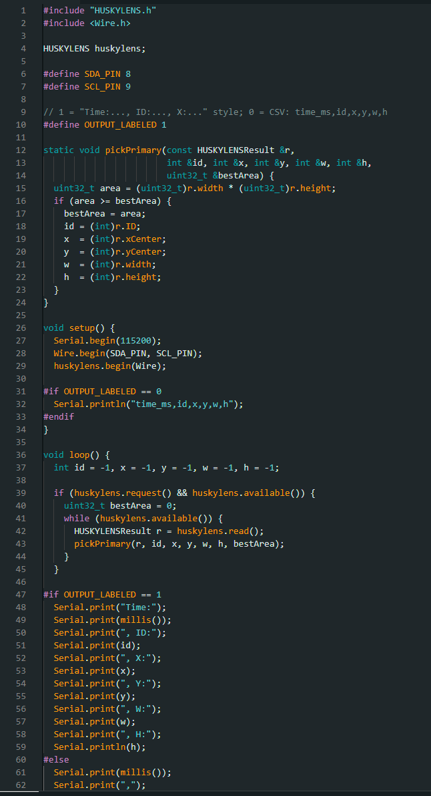
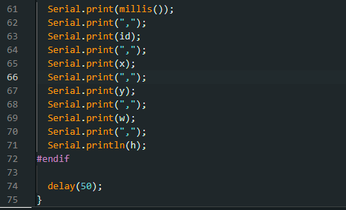

HuskyLens Object Classification Test Results
HuskyLens was interfaced with the ESP32-S3 Zero over I2C and configured in object-recognition/classification mode. Three fixed objects were trained on HuskyLens (IDs 1-3) and used consistently across runs. Serial output (time_ms, det_count, class_id, x, y, w, h) was logged in three independent runs (~60 s each) under fixed camera placement and consistent scene conditions. Performance was evaluated using update rate (FPS), detection reliability, and class output stability.
Logged fields and validity rule
- Each logged sample contains: time_ms, det_count, class_id, x, y, w, h.
- A valid detection is any row where class_id ≥ 0 and x, y, w, h ≥ 0. A no-detection row is represented by class_id = -1 and box fields set to -1.
Calculation method
$$\text{Duration (s)}=\frac{t_{last}-t_{first}}{1000} \\ \text{FPS}=\frac{N-1}{\text{Duration}}$$

Table 1. Per-run results (Object Classification)
Run | Scenario | Samples (N) | Duration (s) | FPS | Valid detections | Detection rate (%) | Unique classes | Class switches
Run 1 | Static (objects A-C) | 2730 | 65.496 | 41.667 | 2730 | 100.000 | 3 | 9
Run 2 | No target (negative) | 2847 | 62.634 | 45.439 | 0 | 0.000 | 0 | 0
Run 3 | Dynamic (motion, swaps) | 2854 | 68.472 | 41.667 | 2854 | 100.000 | 3 | 26

Table 2. Bounding-box statistics (valid detections only)
Run | x mean ± std | y mean ± std | w mean ± std | h mean ± std | x range | y range | w range | h range
Run 1 | 160.000 ± 0.000 | 112.000 ± 0.000 | 224.000 ± 0.000 | 224.000 ± 0.000 | 160-160 | 112-112 | 224-224 | 224-224
Run 2 | N/A | N/A | N/A | N/A | N/A | N/A | N/A | N/A
Run 3 | 160.000 ± 0.000 | 112.000 ± 0.000 | 224.000 ± 0.000 | 224.000 ± 0.000 | 160-160 | 112-112 | 224-224 | 224-224

Combined summary (all runs)
- Total samples: 8431
- Total duration: 196.602 s
- Weighted average FPS: 42.868 FPS
- Overall means (valid detections only): x = 160.000, y = 112.000, w = 224.000, h = 224.000
- Overall standard deviations (valid detections only): x = 0.000, y = 0.000, w = 0.000, h = 0.000
Discussion
- Run 1 (static): stable classification across the fixed object set, with detections present throughout and limited class switching.
- Run 2 (no target): correct negative behaviour with no valid detections recorded; bounding-box statistics are not defined and are reported as N/A.
- Run 3 (dynamic): consistent detections during object swaps and motion, with increased class switching during transitions between objects.
Conclusion for this test block
The object-classification tests confirm that HuskyLens + ESP32-S3 Zero can provide stable, comparable outputs (class_id and bounding box x, y, w, h) suitable for cross-platform benchmarking. The negative run verified false-positive control, and the dynamic run demonstrated correct behaviour under object changes and motion.

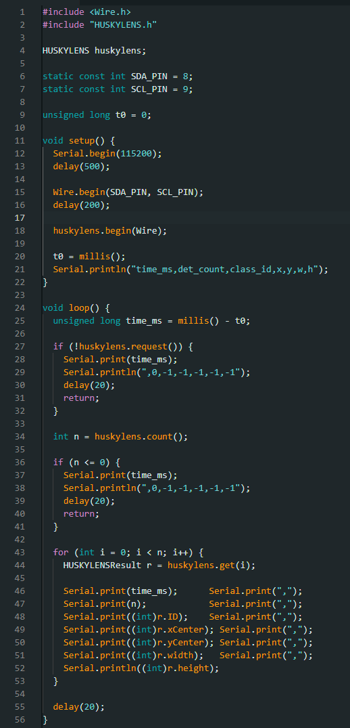

HuskyLens Face-Detection Test Results
HuskyLens was interfaced with the ESP32-S3 Zero over I2C and configured in face-detection mode. Serial output (time_ms, det_count, id, x, y, w, h) was logged in three independent runs under fixed camera placement and consistent scene conditions. Performance was evaluated using update rate (FPS), detection reliability (valid vs no-detection frames), and bounding-box stability.
Logged fields and validity rule
- time_ms: elapsed time from start of logging (ms)
- det_count: number of faces returned at that time step
- id: face ID (or -1 when no face detected)
- x, y: bounding-box centre (pixels; -1 when no face detected)
- w, h: bounding-box width and height (pixels; -1 when no face detected)
A valid detection is any row where id ≥ 0 and x, y, w, h ≥ 0. A no-detection row is represented by id = -1 and box fields set to -1.
Calculation method
$$\text{Duration (s)}=\frac{t_{\text{last}}-t_{\text{first}}}{1000} \\ \text{FPS}=\frac{N-1}{\text{Duration}} \\ \text{Detection rate (\%)}=\frac{N_{\text{valid}}}{N}×100$$
- $N$: total logged samples
- $N_{\text{valid}}$: samples with a valid face box

Table 1. Per-run results (Face Detection)

Run | Scenario | Samples (N) | Duration (s) | FPS | Valid detections | Detection rate (%) | Unique IDs | ID switches
Run 1 | Single face | 2698 | 64.728 | 41.667 | 2698 | 100.000 | 1 | 0
Run 2 | No face (negative) | 3129 | 68.838 | 45.440 | 0 | 0.000 | 0 | 0
Run 3 | Dynamic (video) | 3322 | 78.338 | 42.393 | 2639 | 79.440 | 1 | 0

Table 2. Bounding-box statistics (valid detections only)
Run | x mean ± std | y mean ± std | w mean ± std | h mean ± std | x range | y range | w range / h range
Run 1 | 146.723 ± 1.355 | 61.878 ± 3.425 | 48.084 ± 0.278 | 72.616 ± 8.639 | 141-150 | 55-69 | 48-49 / 64-82
Run 2 | N/A | N/A | N/A | N/A | N/A | N/A | N/A
Run 3 | 133.736 ± 6.347 | 67.043 ± 5.373 | 46.385 ± 3.874 | 63.578 ± 3.172 | 117-151 | 50-75 | 31-49 / 41-65

Combined summary (all runs)
- Total samples: 9149
- Total duration: 211.904 s
- Weighted average FPS: 43.161 FPS
Overall means (valid detections only):
- x = 140.301, y = 64.432, w = 47.244, h = 68.147
Overall standard deviations (valid detections only):
- x = 7.938, y = 5.184, w = 2.861, h = 7.945

Discussion
- Run 1 (single face): continuous face detection with stable localisation and a single tracked ID; no ID switching events.
- Run 2 (no face): correct negative behaviour with zero valid detections; bounding-box statistics are not defined and are reported as N/A.
- Run 3 (dynamic): detection remained strong under motion and pose variation, with increased spread in x/y and box size as expected. The dynamic stimulus used a repeatable talking-head video played on a screen to introduce movement, distance change, and brief occlusion while keeping the camera rig fixed.

Conclusion for this test block
HuskyLens + ESP32-S3 Zero produced consistent face-detection outputs (id, x, y, w, h) at ~43 FPS overall, with correct negative-control behaviour and stable single-ID tracking when a face was present. Dynamic conditions increased bounding-box variability as expected, supporting the use of this logging method for fair cross-platform benchmarking.

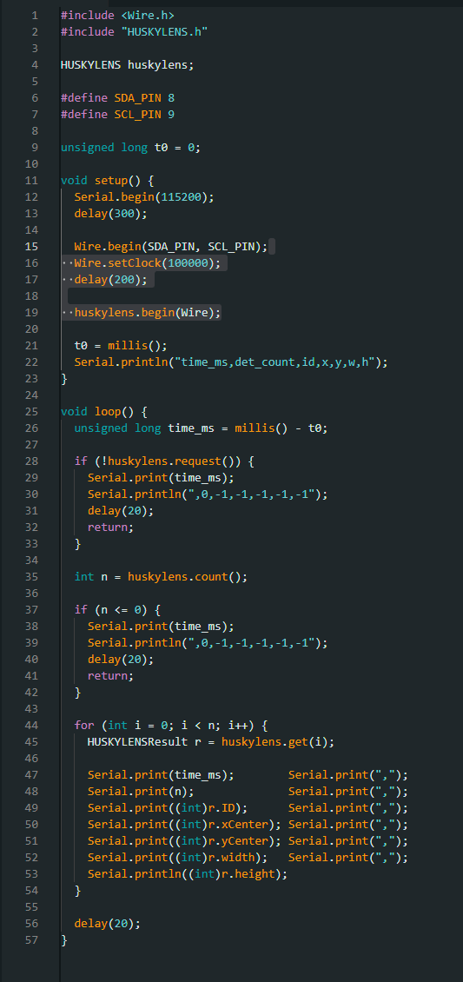
HuskyLens Colour Block Detection (RGB) Test Results
HuskyLens was interfaced with the ESP32-S3 Zero over I2C and configured in colour recognition / colour block mode. Because HuskyLens can only store one colour target at a time, Test 4 was executed as three per-colour sub-tests (Red, Green, Blue). For each colour target, serial output (time_ms, det_count, colour_id, x, y, w, h) was logged in three independent runs (~60 s each) under fixed camera placement and consistent scene conditions. Performance was evaluated using update rate (FPS), detection reliability (valid vs no-detection frames), and bounding-box stability.
Logged fields and validity rule
- time_ms: elapsed time from start of logging (ms)
- det_count: number of detected colour blocks returned at that time step
- colour_id: detected colour ID (or -1 when no detection)
- x, y: bounding-box centre (pixels; -1 when no detection)
- w, h: bounding-box width and height (pixels; -1 when no detection)
A valid detection is any row where colour_id ≥ 0 and x, y, w, h ≥ 0. A no-detection row is represented by colour_id = -1 and box fields set to -1.
Run definitions (applied to every colour)
- Run 1 (static): single colour card present, fixed distance, minimal motion.
- Run 2 (no target): card removed completely (negative control).
- Run 3 (dynamic): first 30 s card moved left/right/up/down across the target area; next 30 s card moved towards the camera and then further away (distance sweep). This same 60 s motion pattern was repeated for red, green, and blue papers.
Calculation method
$$\text{Duration (s)}=\frac{t_{\text{last}}-t_{\text{first}}}{1000} \\ \text{FPS}=\frac{N-1}{\text{Duration}} \\ \text{Detection rate (\%)}=\frac{N_{\text{valid}}}{N}×100$$
- $N$: total logged samples
- $N_{\text{valid}}$: samples with a valid colour box

Table 1. Per-run results (Colour Block Detection — Red)
Run | Scenario | Samples (N) | Duration (s) | FPS | Valid detections | Detection rate (%) | Unique IDs | ID switches
Run 1 | Static single target (Red card) | 2591 | 62.160 | 41.667 | 2591 | 100.000 | 1 | 0
Run 2 | No target (negative) | 2779 | 61.138 | 45.438 | 0 | 0.000 | 0 | 0
Run 3 | Dynamic motion (Red card) | 2784 | 63.812 | 43.612 | 2746 | 98.635 | 1 | 0
Table 2. Bounding-box statistics (valid detections only — Red)
Run | x mean ± std | y mean ± std | w mean ± std | h mean ± std | x range | y range | w range | h range
Run 1 | 169.333 ± 4.172 | 111.223 ± 4.854 | 196.971 ± 7.228 | 139.282 ± 8.802 | 160–175 | 102–125 | 190–215 | 127–163
Run 2 | N/A | N/A | N/A | N/A | N/A | N/A | N/A | N/A
Run 3 | 163.818 ± 47.926 | 93.685 ± 32.589 | 162.929 ± 54.425 | 133.202 ± 51.701 | 14–299 | 1–192 | 8–319 | 2–214

Combined summary (Red, all runs):
- Total samples: 8154
- Total duration: 187.110 s
- Weighted average FPS: 43.563 FPS
- Overall means (valid detections only): x = 166.496, y = 102.200, w = 179.455, h = 136.154
- Overall standard deviations (valid detections only): x = 34.607, y = 25.192, w = 42.880, h = 37.708
Discussion (Red):
- Run 1 showed stable detection with low box variation under fixed conditions.
- Run 2 produced correct negative behaviour (no valid detections; fields remained -1).
- Run 3 maintained detection under motion and distance change, increasing box variability as expected.

- Table 1. Per-run results (Colour Block Detection — Green)
Run | Scenario | Samples (N) | Duration (s) | FPS | Valid detections | Detection rate (%) | Unique IDs | ID switches
Run 1 | Static single target | 2589 | 62.112 | 41.667 | 2589 | 100.000 | 1 | 0
Run 2 | No target (negative) | 2825 | 62.172 | 45.422 | 0 | 0.000 | 0 | 0
Run 3 | Dynamic motion | 2776 | 64.130 | 43.271 | 2378 | 85.663 | 1 | 0
Table 2. Bounding-box statistics (valid detections only — Green)
Run | x mean ± std | y mean ± std | w mean ± std | h mean ± std | x range | y range | w range | h range
Run 1 | 177.902 ± 1.763 | 109.054 ± 3.933 | 193.329 ± 3.042 | 148.390 ± 11.909 | 173–184 | 100–125 | 181–201 | 134–181
Run 2 | N/A | N/A | N/A | N/A | N/A | N/A | N/A | N/A
Run 3 | 163.656 ± 38.358 | 114.221 ± 28.201 | 141.681 ± 42.484 | 129.557 ± 50.365 | 58–251 | 5–192 | 9–233 | 7–211

Combined summary (Green, all runs):
- Total samples: 8190
- Total duration: 188.414 s
- Weighted average FPS: 43.452 FPS
- Overall means (valid detections only): x = 171.081, y = 111.528, w = 168.602, h = 139.373
- Overall standard deviations (valid detections only): x = 27.505, y = 19.884, w = 39.173, h = 37.103
Discussion (Green):
- Run 1 showed stable green detection under fixed conditions.
- Run 2 confirmed negative control (no detections).
- Run 3 increased box spread due to the defined motion pattern, while maintaining reliable detection.

Table 1. Per-run results (Colour Block Detection - Blue)
Run | Scenario | Samples  (N) | Duration  (s) | FPS | Valid  detections | Detection  rate  (%) | Unique  IDs | ID  switches
Run 1 | Static  single  target | 2637 | 63.288 | 41.651 | 2637 | 100.000 | 1 | 0
Run 2 | No target  (negative) | 2849 | 62.700 | 45.423 | 0 | 0.000 | 0 | 0
Run 3 | Dynamic  motion | 2832 | 65.326 | 43.336 | 2689 | 94.951 | 1 | 0

Table 2. Bounding-box statistics (valid detections only - Blue)
Run | x mean ±  std | y mean ±  std | w mean ±  std | h mean ±  std | x range | y range | w range | h range
Run 1 | 161.772 ±  1.531 | 110.430 ±  4.598 | 195.809 ±  2.789 | 186.056 ±  4.768 | 156-165 | 104-122 | 189-203 | 174-195
Run 2 | N/A | N/A | N/A | N/A | N/A | N/A | N/A | N/A
Run 3 | 186.097 ±  43.270 | 105.010 ±  26.830 | 158.897 ±  58.054 | 146.383 ±  66.412 | 29-293 | 3-205 | 7-255 | 2-237

Combined summary (Blue, all runs):
- Total samples: 8318
- Total duration: 191.314 s
- Weighted average FPS: 43.463 FPS
- Overall means (valid detections only): x = 174.054, y = 107.693, w = 177.173, h = 166.026
- Overall standard deviations (valid detections only): x = 33.079, y = 19.524, w = 45.231, h = 51.295
Discussion (Blue):
- Run 1 produced stable detection with low variation.
- Run 2 showed correct negative behaviour (no detections).
- Run 3 increased box variability due to lateral and depth motion, confirming robustness measurement under the same dynamic protocol.

Overall conclusion for Test 4 (RGB)
Across the three per-colour sub-tests, HuskyLens + ESP32-S3 Zero delivered consistent colour-block outputs (colour_id, x, y, w, h) at ~43 FPS, with correct negative-control behaviour and predictable increases in bounding-box variability under the defined dynamic motion pattern. Treating RGB as three controlled sub-tests preserves fairness while matching HuskyLens’ single-colour storage constraint.

Across the full HuskyLens baseline test suite (tracking, classification, face detection, and RGB colour block detection), the platform produced consistent, comparable bounding-box outputs under a fixed rig, with negative-control runs (no target/no face/no colour) correctly returning zero valid detections. Object tracking achieved a weighted mean of ~18.8 FPS with high detection reliability (100% static; 97.4% dynamic) and stable single-ID behaviour (no ID switches). Object classification ran at ~42.9 FPS with 100% valid detections in both static and dynamic runs on the three-object set, with class switching mainly occurring during object transitions. Face detection delivered ~43.2 FPS overall, with 100% detection in the single-face run and ~79.4% detection under dynamic video stimulus, again maintaining a single ID without switching. For colour block detection, treating RGB as three controlled sub-tests (due to single-target storage), throughput remained ~43 FPS for red/green/blue with strong detection in static runs and expected variability in dynamic runs, while maintaining correct negative behaviour and no ID switching. Overall, HuskyLens provides a robust reference baseline for cross-platform benchmarking by combining repeatable logging, reliable negative control, and predictable increases in box variability under motion

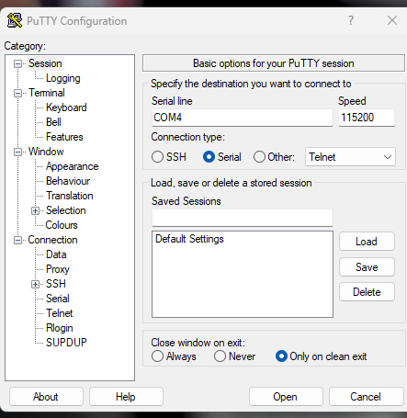
“Minimal movement” just means the target stays stationary (or only tiny accidental shifts).

